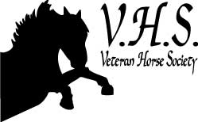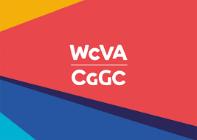

Position: Digital Marketing Manager
Hours: 35 hours (flexible which will include evenings and weekends)
Description:
A full time role to oversee and develop all platforms of the Society and charity. To have excellent IT skills and to be able to develop all social media aspects of the Society. To be based working at home and (when possible) Head Office of the Society.
Assist in developing the Membership base and attend equine events and shows (where possible) and promote the digital aspect of the Society and also to assist with fund raising and promotional work.
To work with the Management Committee and also a team of volunteers, therefore excellent communication skills are required. The successful candidate needs to hold a clean driving license .
A good understanding of veteran horses is preferred but not essential.
This position is currently reviewed after 1 year and is currently funded by the Welsh Voluntary Community Association.

Application forms are available by email info@veteran-horse-society.co.uk

